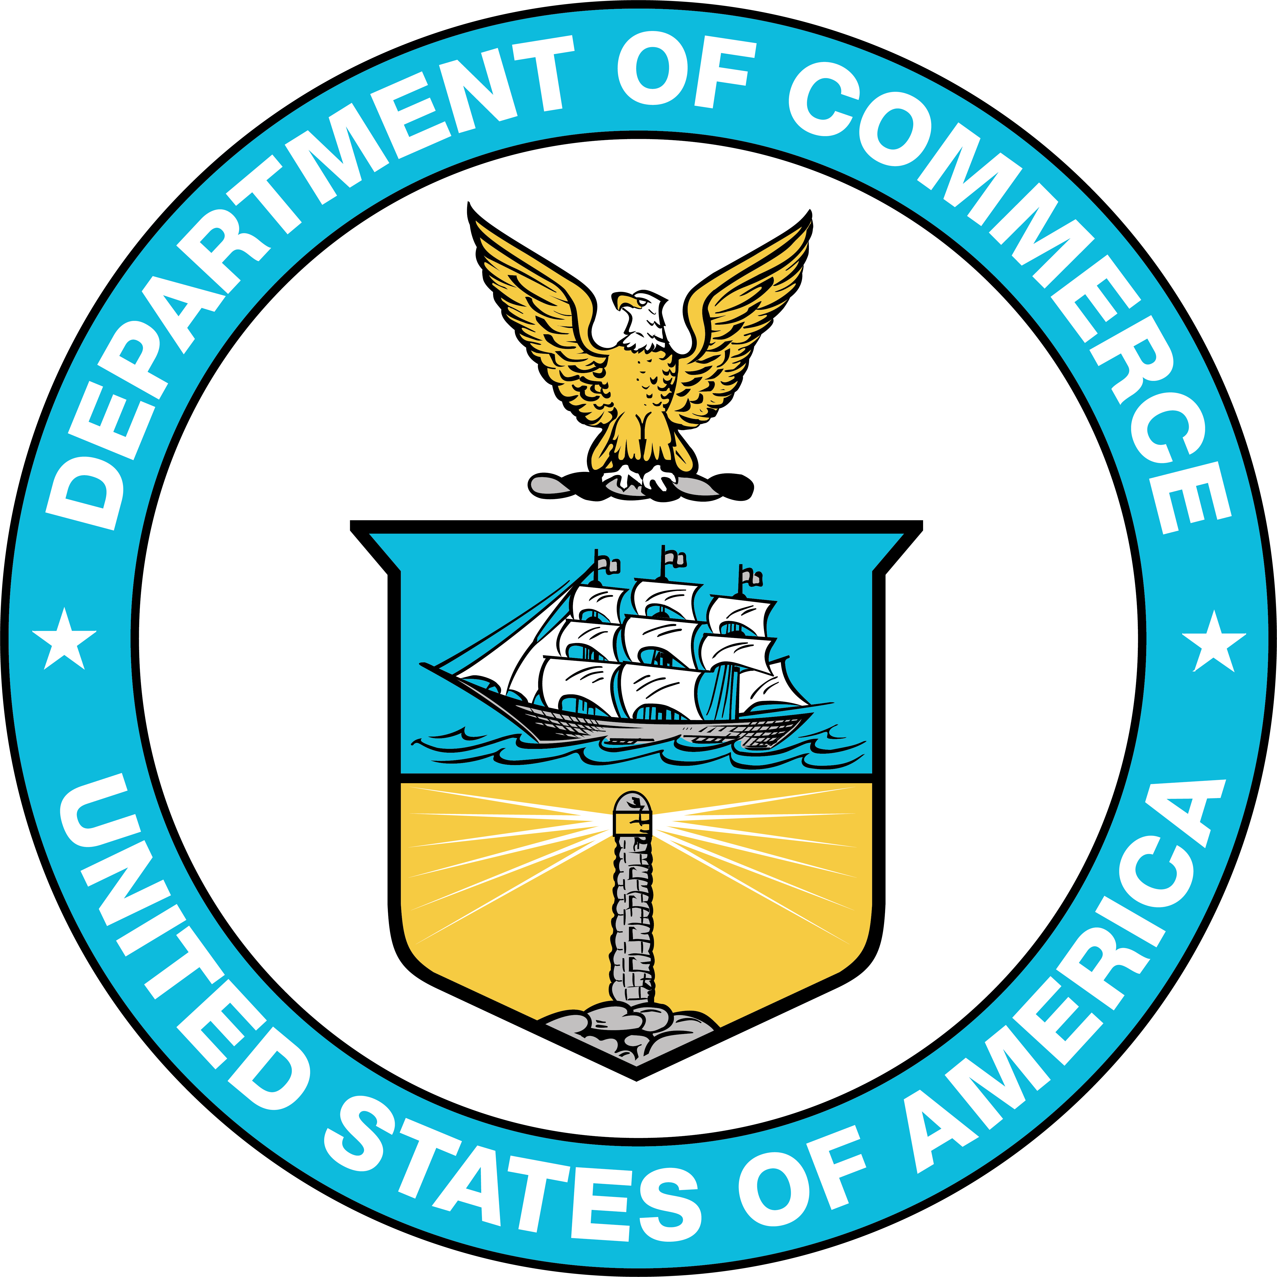

STATEMENT OF

Robert O’Leary

Deputy Assistant Secretary for Travel and Tourism
National Travel and Tourism Office
International Trade Administration
U.S. Department of Commerce

FOR A HEARING ON

“A Review of Preparations for the FIFA World Cup 2026”

BEFORE THE

United States Senate
Committee on Appropriations
Subcommittees on Commerce, Justice, Science, and Related Agencies
& Homeland Security

April 15, 2026

Chairman Moran, Chairwoman Britt, Ranking Member Van Hollen, Ranking Member Murphy, and members of the Subcommittee, thank you for the opportunity to update you on the Commerce Department’s preparations for the 2026 FIFA World Cup as related to travel and tourism – a critical industry that continues to receive immense support from this subcommittee. Thank you for your leadership in this area.

My name is Robert O’Leary. I serve as the Deputy Assistant Secretary for Travel and Tourism at the International Trade Administration within the U.S. Department of Commerce, and I’m truly honored to join you today at such a dynamic and impactful moment for the U.S. travel and tourism industry.

The success of the 2026 FIFA World Cup is a priority for the Trump Administration. To underscore its importance, on March 7, 2025, President Trump signed Executive Order 14234, Establishing the White House Task Force on the FIFA World Cup 2026, to coordinate U.S. Government efforts related to the 2025 FIFA Club World Cup and FIFA World Cup 2026. This year’s Tournament will be the largest sporting event in history, as 48 teams play 104 matches in 16 cities across three countries. As the President stated in the Executive Order, this event will provide America the opportunity to showcase the Nation’s pride and hospitality while promoting economic growth and tourism through sport.

As America’s largest service export, international travel and tourism is a vital part of the American economy. In 2025, 68.3 million international visitors traveled to the United States, generating $250 billion in travel and tourism exports and injecting, on average, $686 million a day into the U.S. economy.

The World Cup is expected to draw millions of visitors from all over the world, creating an exceptional opportunity to expand tourism revenues in 2026.

According to FIFA and the World Trade Organization estimates, the Tournament will create 185,000 full-time jobs in the United States, deliver $30.5 billion in gross output, and contribute over 17 billion dollars to our nation’s gross domestic product – illustrating the substantial economic impact that the World Cup will generate across the United States.

FIFA predicts that 3.5 million tickets will be purchased by international fans, with travel and tourism spending across the U.S., Canada, and Mexico at about $7.5 billion. Of this total, the United States alone will account for $6.4 billion of this anticipated visitor spending.

When President Trump established the White House Task Force on the FIFA World Cup 2026 early last year, he set a clear mission: to ensure the United States delivers a safe, welcoming, and memorable World Cup. And that’s exactly what the White House Task Force is working to deliver – the biggest and most successful sporting event in American history. Billions of viewers will be watching the Tournament, and we want to turn those viewers into millions of future visitors to the United States.

To help support this goal, we are focused on several key priorities – starting with measuring the economic impact.

As the official source for U.S. government data on international visitation and spending in the United States, the Commerce Department’s National Travel and Tourism Office (NTTO) is leading Task Force efforts to measure the economic impact of international visitors during the World Cup, so that we can clearly understand and successfully communicate how this global event – and sports tourism more broadly – benefits local communities, businesses, and the U.S. economy as a whole.

Starting in January 2026, NTTO rolled out a modified Survey of International Air Travelers that now asks survey respondents whether they attended a FIFA World Cup 2026 match or fan event during their visit to the United States. This information will allow us to better understand who is coming for the World Cup, how they are traveling, and how much they are spending.

For host cities and other destinations across the country, this data will help provide better insight into demand, traveler behavior, and spending patterns – information that can be leveraged to develop stronger itineraries, identify new market opportunities, and demonstrate the value of travel experiences well beyond the stadiums in order to help these communities successfully communicate the economic benefits of the World Cup.

Commerce is also working to support travelers and the travel industry. As the main point of contact for the industry within the U.S. Government, we are focused on clear communication and working with other agencies to highlight streamlined travel processes for both the industry and potential visitors, helping to ensure the visitor experience matches the scale and significance of the event.

Our third area of focus is on engagement and partnership. We are actively engaging with host city committees, destination marketing organizations, industry associations, and Brand USA to promote travel throughout the United States and to ensure stakeholders have what they need to maximize the success of the Tournament.

Thanks to President Trump’s leadership, the World Cup is only the start of a decade of mega tourism events hosted in the United States, including America250, the Los Angeles 2028 Summer Olympic and Paralympic Games, the Men’s and Women’s Rugby World Cups, the 2034 Winter Olympics and Paralympic Games in Park City, Utah, and a potential bid for the Women’s World Cup in 2031. We are also exploring the possibility of hosting one or more international expositions in the United States. All of these events present a remarkable opportunity for the United States. The Commerce Department is working to build a foundation that will not only ensure the success of these events but also create a long-term legacy lasting far beyond the 2026 World Cup.

In summary, Commerce appreciates the opportunity to update the committee during this pivotal moment for travel and tourism in the United States. Through continued public-private sector collaboration, we will expand opportunities for travelers from around the world not only to experience this unprecedented event, but also to meet the people and visit the extraordinary places that make the United States the world’s premier travel destination – and to once again remind the world that nobody can host a major event like the United States.

Thank you for having me here today. I look forward to answering your questions.

